**EXPAND THE CONTENT SECTION**

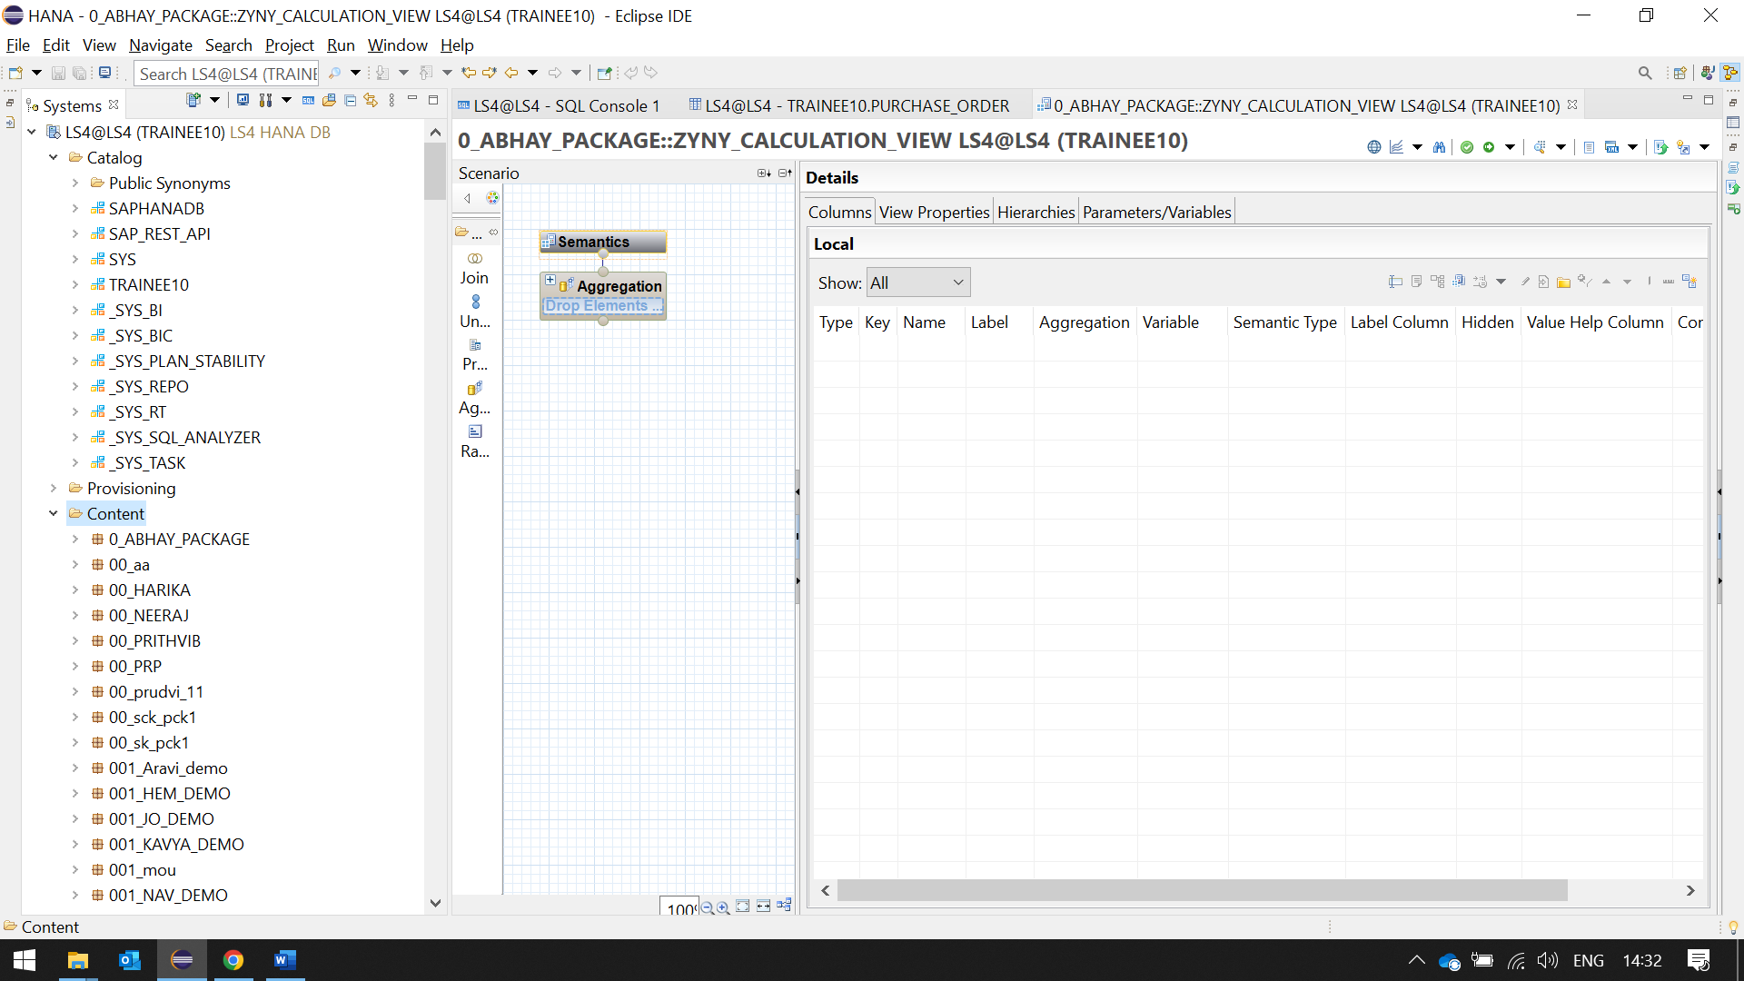

**THEN CREATE A PACKAGE** 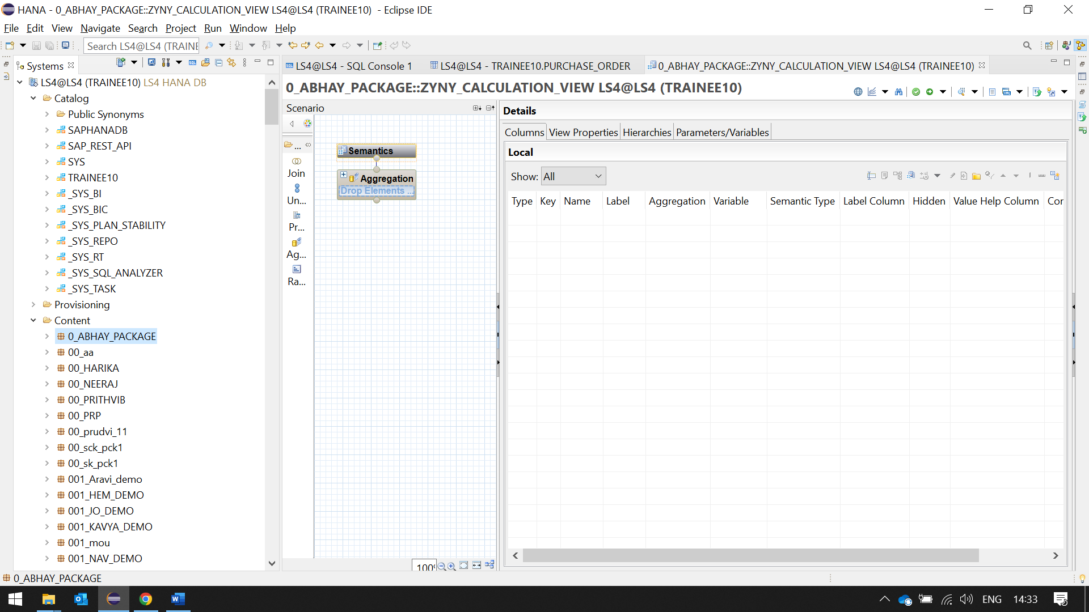

**A)**Create Dimension Calculation Views for dimensions (“EMPDAT_DIM” on “EMPDATE” and EMPLOYEE_DIM on EMPDIM).

**A.1)**From the input Select the **“Dimension”** from the pull-down menu while from the Create pop-up screen.

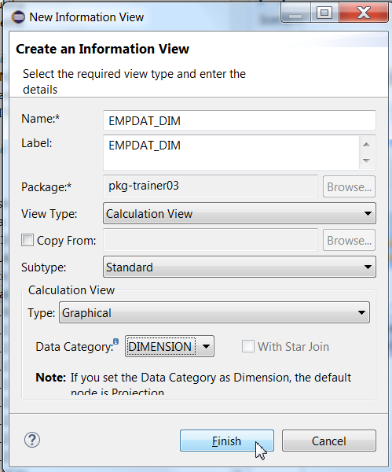

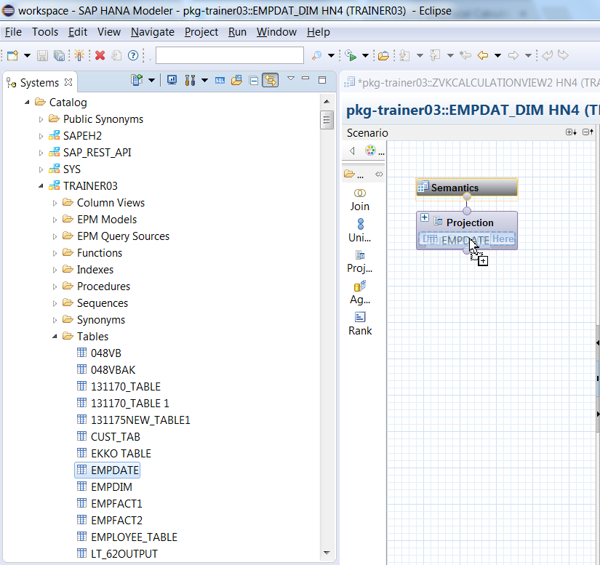

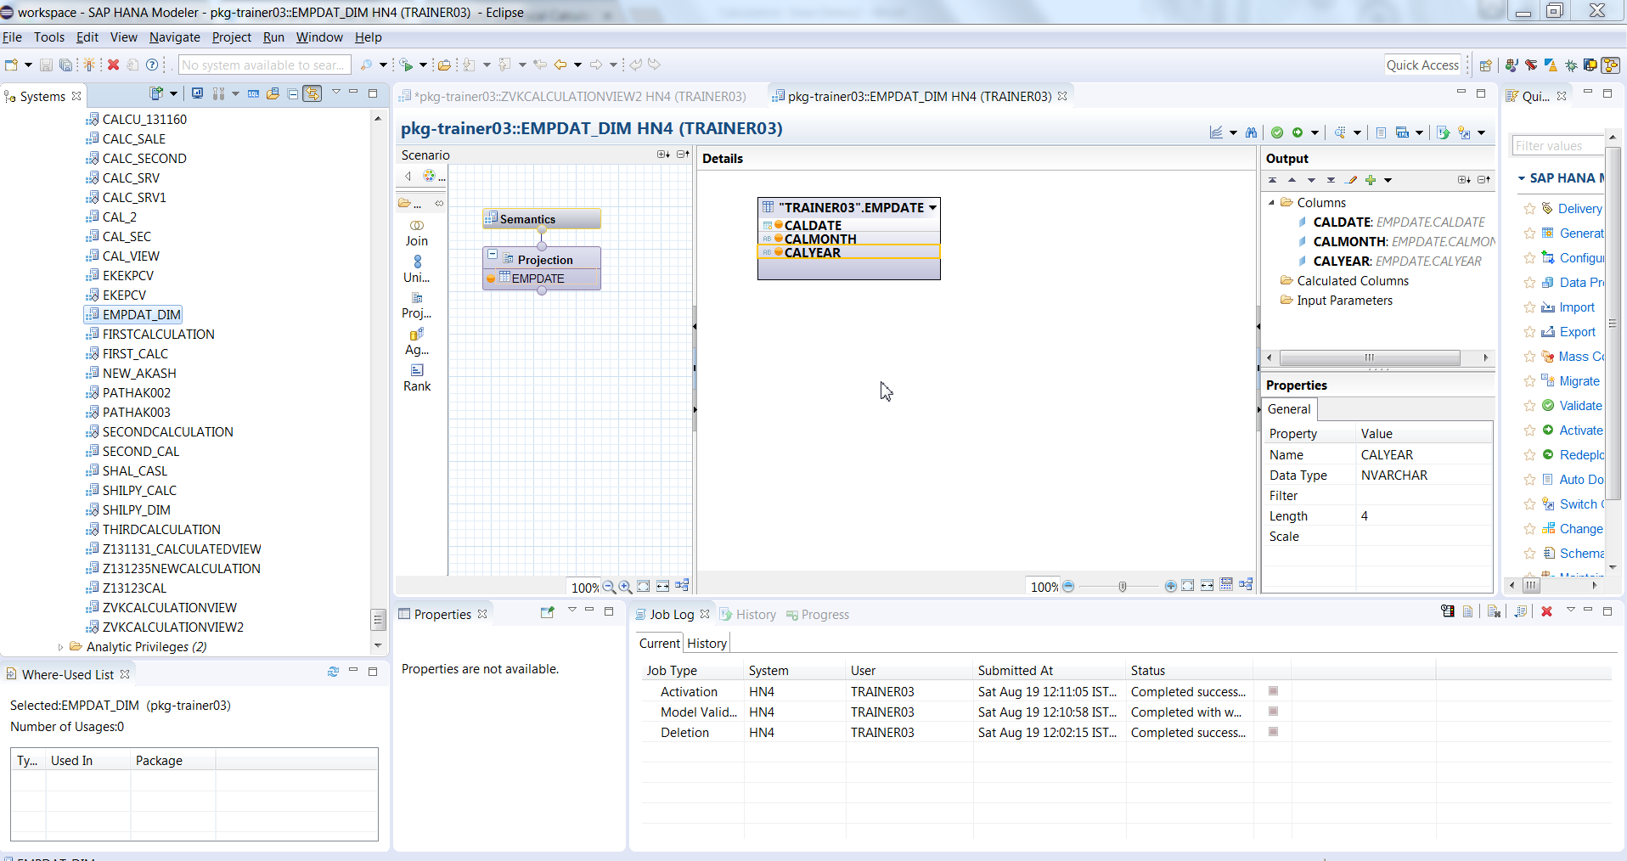

Validate, Activate.

**A.2)**From the input Select the **“Dimension”** from the pull-down menu while from the Create pop-up screen. Name this Calculation view as EMPLOYEE_DIM

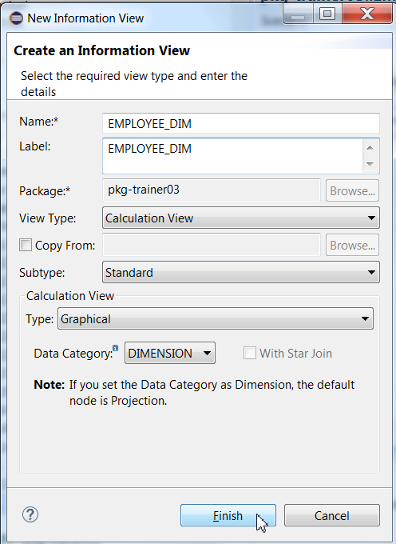

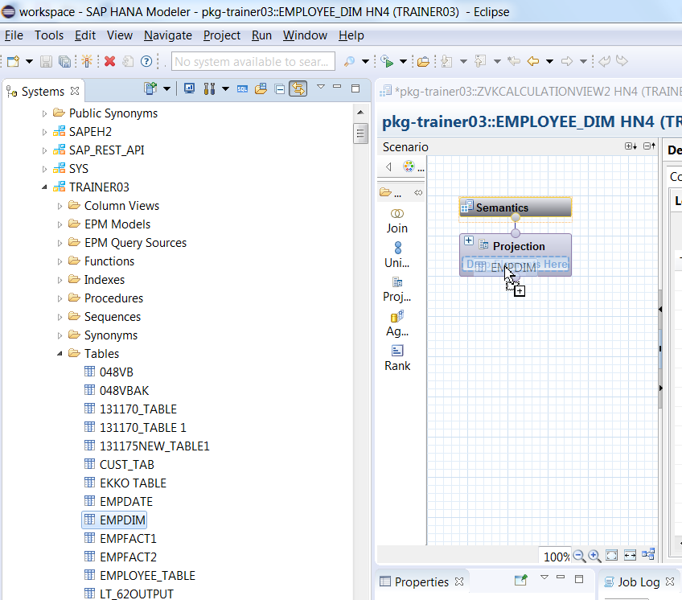

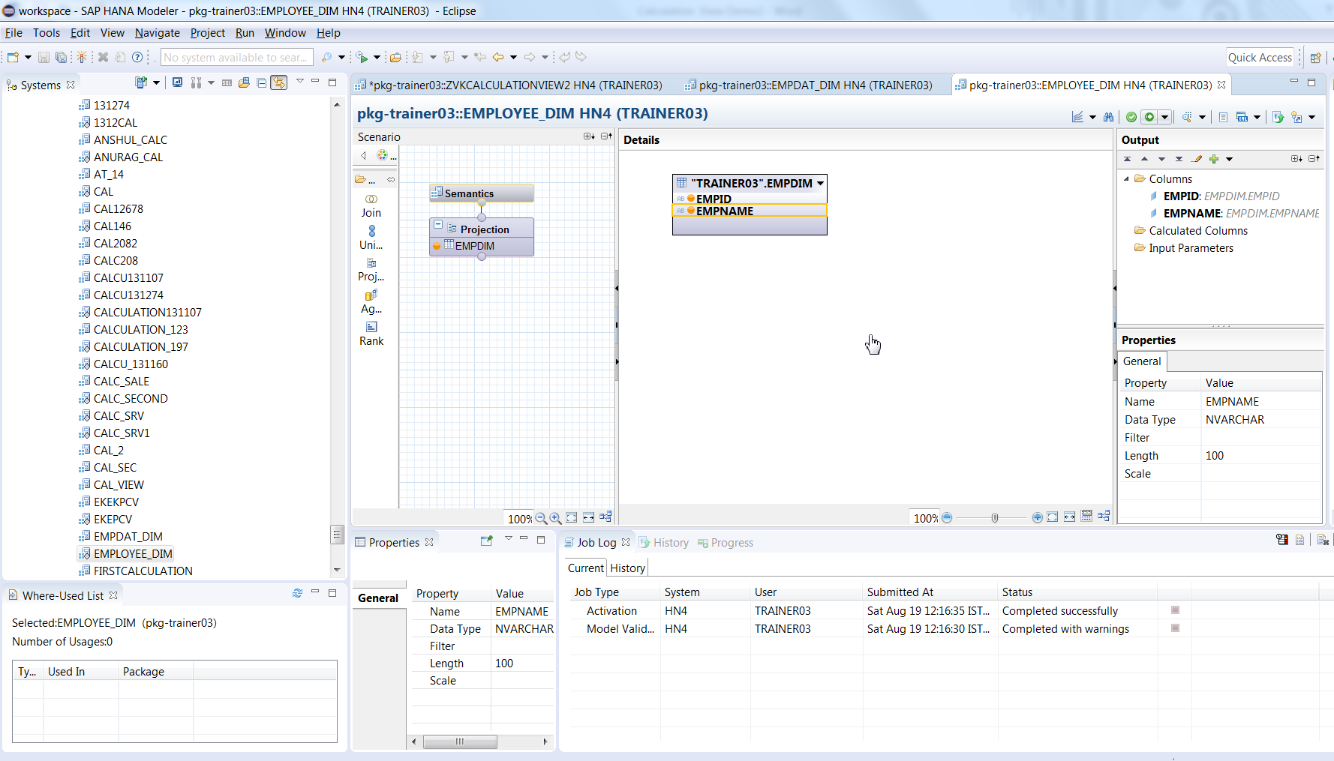

Validate, Activate.

The above steps create 2 Dimension Calculation Views.

Proceed with the steps below after the above 2 Dimension calculation views are created.

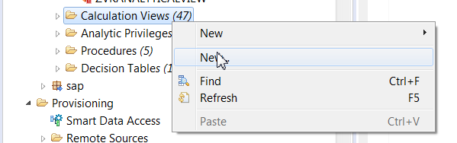

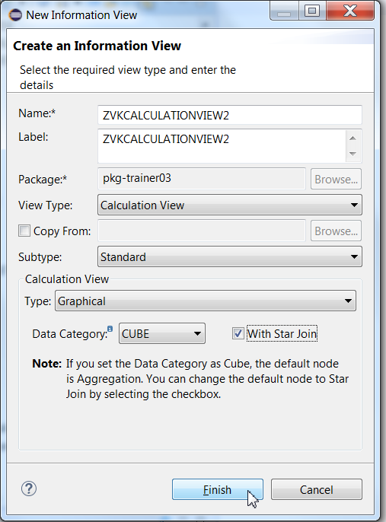

In Graphical pane, add 2 Projections for 2 Fact tables. Add both fact tables to both Projections and add attributes of these Projections to Output pane.

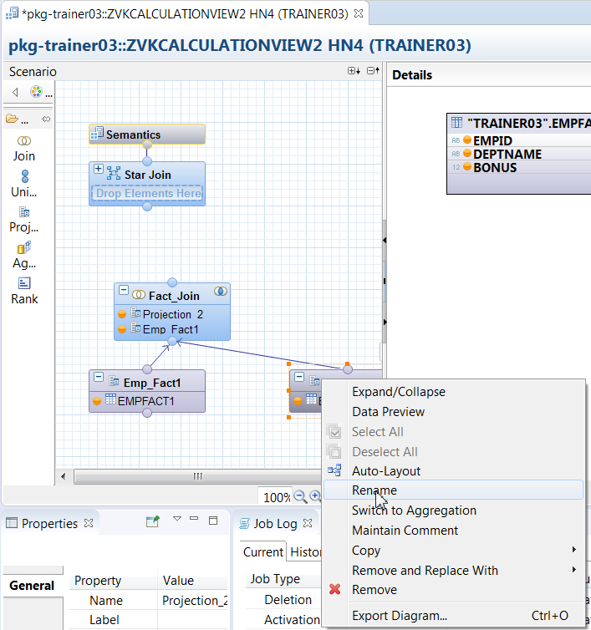

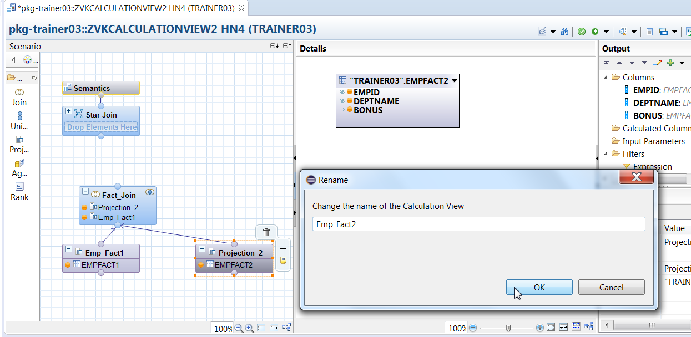

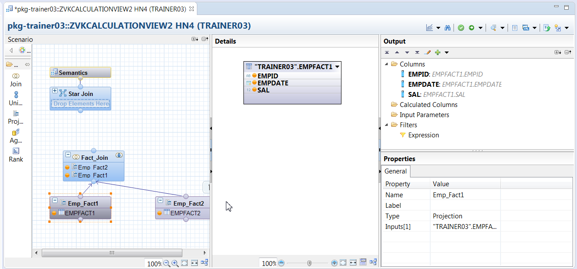

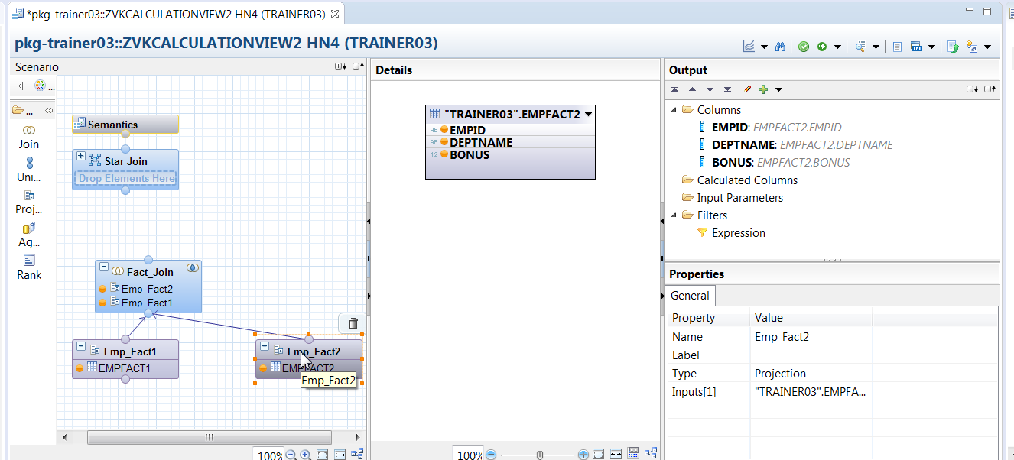

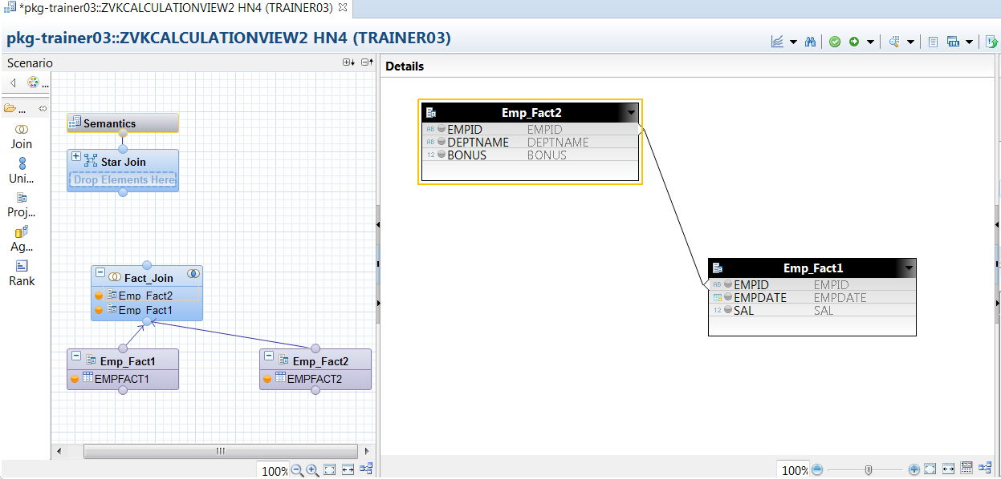

Add the above 2 Dimension calculation views in the Star Join Node.

